Roll No.:2503a52531
Name:B.Poojitha
Batch:18
Question 1. Sentiment Classification for Customer Reviews
Scenario:
An e-commerce platform wants to analyze customer reviews and classify
them into Positive, Negative, or Neutral sentiments using prompt
engineering.
Tasks:
a) Prepare 6 short customer reviews mapped to sentiment labels.
b) Design a Zero-shot prompt to classify sentiment.
c) Design a One-shot prompt with one labeled example.
d) Design a Few-shot prompt with 3–5 labeled examples.
e) Compare the outputs and discuss accuracy differences.

Prompt for ZERO-SHOT:
Classify the following customer review as Positive, Negative, or Neutral: "The product is good and works well."

Code for ZERO-SHOT:
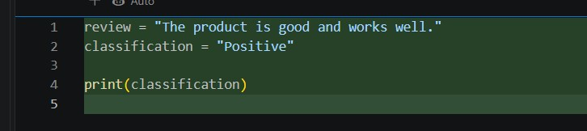

Output:
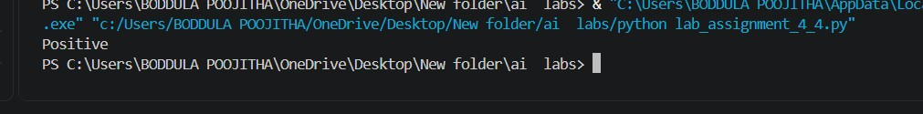

Prompt for ONE-SHOT:
Classify customer reviews as Positive, Negative, or Neutral.
Example: "The product is amazing." → Positive
Review: "The delivery was very late."

Code for ONE-SHOT:
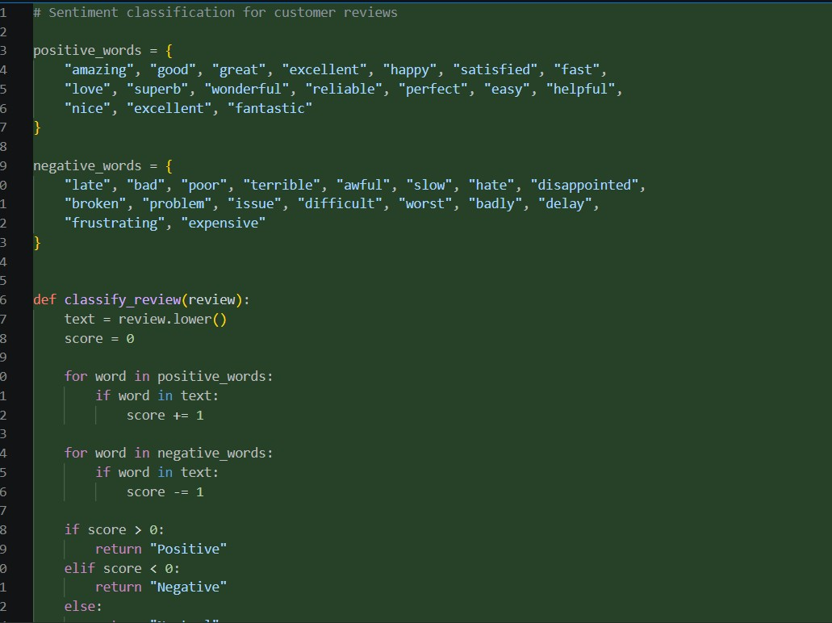
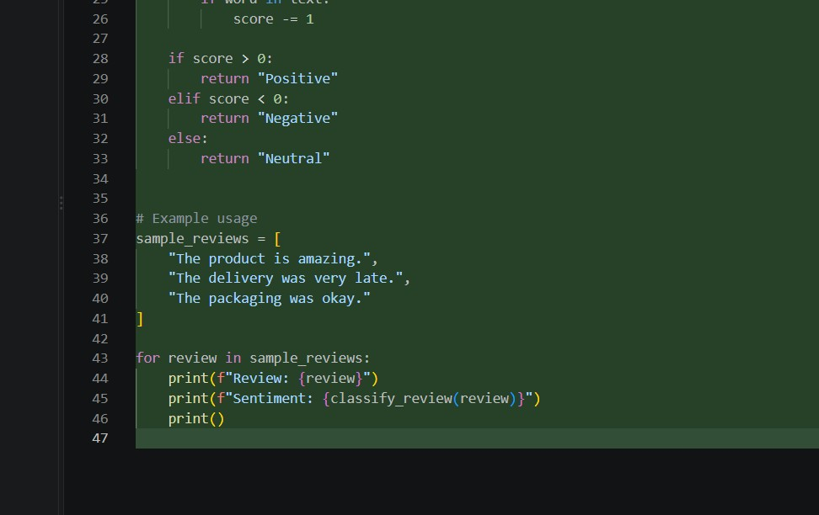

Output:
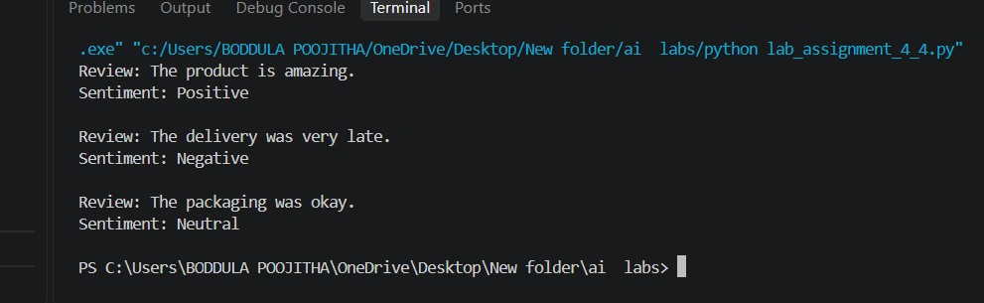

Prompt for FEW-SHOT:
Classify customer reviews as Positive, Negative, or Neutral.
"Excellent product." → Positive
"Very poor quality." → Negative"
The product is okay." → Neutral
"Fast delivery and good service." → Positive
Review: "I am not satisfied with the product."
Code for FEW-SHOT:
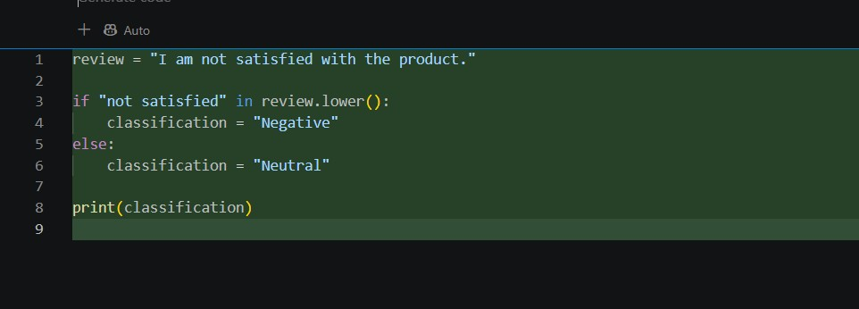

Output:
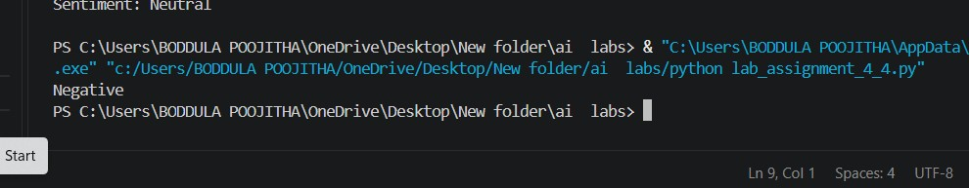

Observations:
1. Zero-shot: Correctly identifies the review as positive based on “the product is good and works well.”
2. One-shot: The example helps the model understand the expected classification format, and the result is Negative, positive and neutral.
3. Few-shot: Multiple examples provide clearer guidance, and the review is classified as Negative.
4. All three prompting techniques give the different correct output for this review.

